DB Lab 14
MongoDB
● List all the employee names, their salaries.
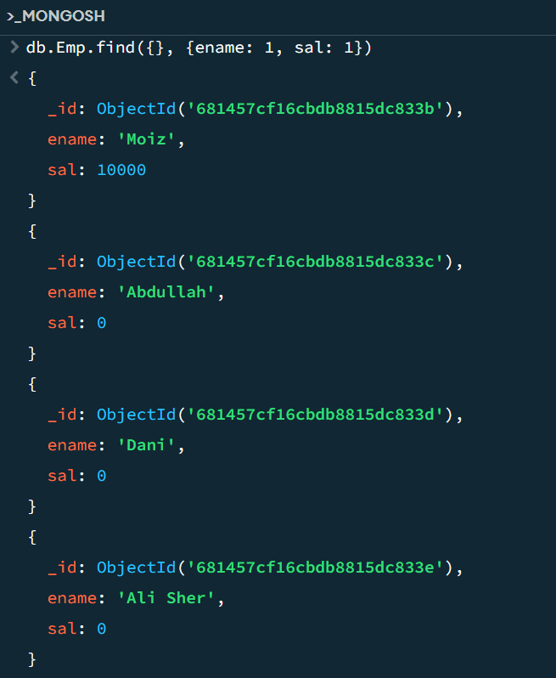
● List all the employee names, jobs, and salaries who have not been given any commission.
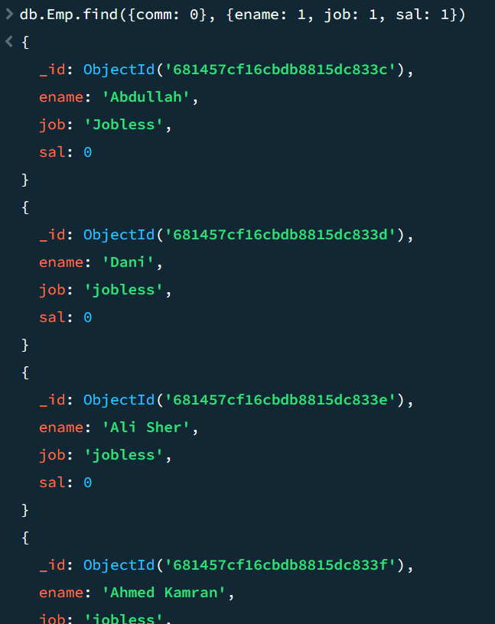
● List all the employee identity numbers, names, jobs, and salaries are greater than 1500
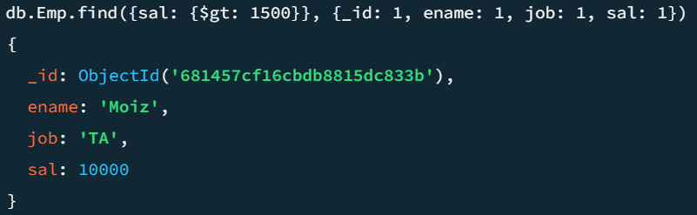
● List all the employee names and jobs who are not CLERK, ANALYST, and SALESMAN.
